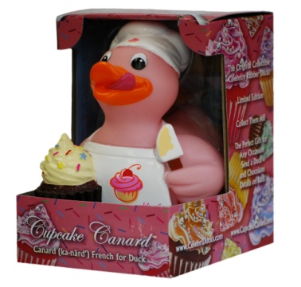Questions:
What promotional product wins the award for the most KEPT product that is rarely ever thrown away?

What promotional product immediately becomes part of a worldwide Collector's Series that has a HUGE following of serious collectors?

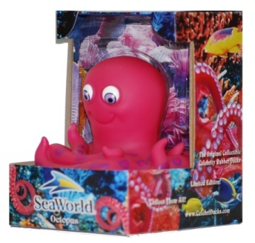What promotional product has been made in the likeness of Elvis, Michael Jackson, Wizard of Oz characters, Barack Obama, athletes, politicians and thousands of other characters for professional sports teams, universities, and Fortune 500 companies?

What promotional product can be packaged in a beautiful custom designed gift box that can tell a unique story in full color on all panels and still show off the product?

If you answered: CelebriDucks.... you are correct!

Next time you have a client wanting something unique, collectible and kept forever....Think... what the duck? CelebriDucks!!

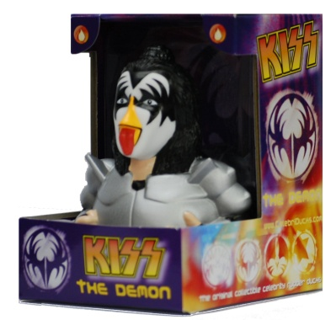Now a little more info about us: CelebriDucks has created an amazing brand which is sold and collected worldwide. Not only do we make some of the finest rubber ducks in the world, but we offer a degree of expertise in all areas of product development. This makes us a one stop shop for people looking to find the most unique and innovative product possible for their customers. There are many reasons why so many professional sports teams and Fortune 500 companies choose to work with us.

The rubber duck was invented in America although all are now made overseas. CelebriDucks has brought the whole rubber duck industry back to the USA and is the only company manufacturing rubber ducks in America! You can read more in the Made in America section on our website.

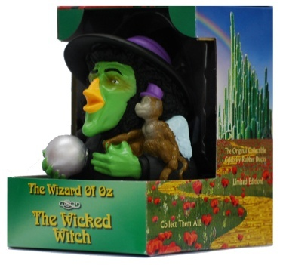It's a fact that so many promotional products people receive are thrown or given away. What is amazing about CelebriDucks is that people actually hold onto our items which make us one of the most sought after promotional products in the country. Our track record to this effect is nothing short of extraordinary! We are considered the top custom duck manufacturer in the world. Many people are surprised when they order a custom rubber duck made overseas and get a very hard piece of plastic, poorly painted, doesn’t float upright, and with very little detail…just a mass market same old same old. We are the Mercedes of rubber ducks which is why the top brands in the world come to us!

1) The quality of our products is unsurpassed. CelebriDucks are recognized to be the most intricately sculpted and painted rubber ducks in the world. The website pictures are a pale comparison to the actual ducks and packaging in real life. Unlike most inexpensive rubber ducks, CelebriDucks all float upright even in rough water and are sealed to prevent any water from getting inside. They are all lead free, phthalate free, and conform to the strictest government safety requirements for any country worldwide.
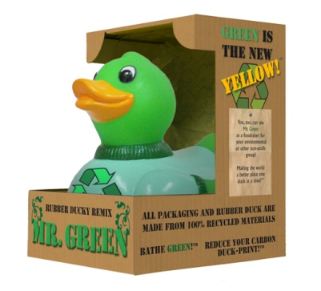
2) GREEN and innovative! Let us Green your promotion. Not only have we pioneered a whole new collectible, but we also always strive to come up with unique products. We can make your promotion Green since we are the ones who pioneered the world's first 100% totally recycled rubber duck. Even all our packaging on all our ducks is recycled. We also came out with an amazing line of Belgian duck chocolates and an all natural green soap that can also be ordered with any of our ducks.

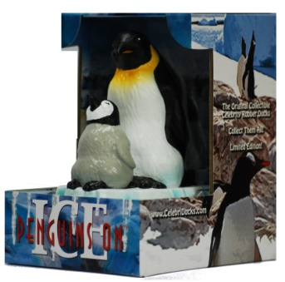3) Quality Control. How nice it is not to worry about the quality of the end product. It is a common complaint in our industry that what is ordered and what arrives from overseas are not the same. Poor painting, poor engineering, and defective packaging are common. With us you get guaranteed customer satisfaction!
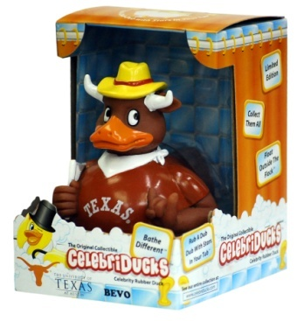
4) Because of our extensive knowledge of how to work through the approval process in terms of artwork and designs, we are able to seamlessly work with your end client in the back and forth design and manufacturing process. Remember, not only do we produce the finest rubber ducks on the market, but we were the largest publisher of artwork from television commercials in the country. We created the first ever animation art lines for Coca-Cola, Anheuser-Bush, M&M/Mars, Pillsbury, Nike, and many others.

5) Expertise. When you have a tight deadline or a very complex and intricate project that demands real expertise, we are the ones you want to call on. We represent over 25 years of design and manufacturing experience.

6) Reliability. In our entire history we have never missed a deadline. What's that worth for peace of mind for you and the client?... Priceless! Working under pressure is second nature for us.

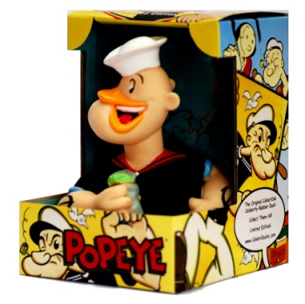7) Flexibility. We can create anything. There is virtually no custom project we cannot do in addition to our world class CelebriDucks. If you go to the custom duck section of our website, you can see examples of some of our work and the tremendous number of well-known clients we have done work for.

8) Fair Pricing. For the quality of work we do and all the extras we add, in the end we can be very competitive. When we quote a price, there are no surprise add-ones. Our prices include everything such as artwork, molds, spray masks, etc., except shipping. It even includes our high-end beautiful gift box which we can customize the box for your client.

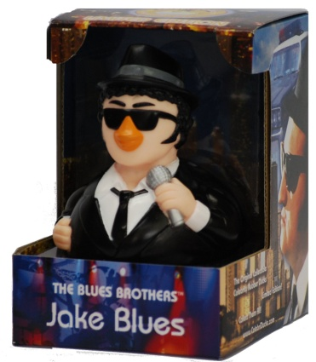And when it comes to pricing, very often we can find ways to adjust a design or project to help meet your client's price points. We often ship our custom jobs along with our other shipments thus saving money in your shipping costs. Although they make a beautiful presentation, our CelebriDucks can also be ordered without gift boxes to save even more.

9) PR Value. If you are looking to get fantastic PR, we are as good as or better than any other similar product on the market having been voted one of the top 100 gifts by Entertainment Weekly. The number of media outlets who love our celebrity rubber ducks is quite amazing. The majority of media outlets who receive one of our ducks will actually do a story about your event thus giving your client tens of thousands of dollars of free publicity!

10) Perceived Value. Due to the fact that we also produce a retail line of CelebriDucks that sell from $12 to $15, the end user will tend to hold on to and treasure it as opposed to just tossing it away after the event. We are a collectible and have built up a very large collectible market worldwide who appreciate our work.

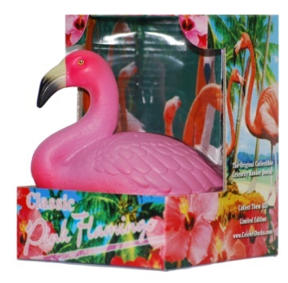11) In Stock Celebrity Ducks. We keep a whole line of celebrity rubber ducks which are immediately available as an alternative when you are looking for a unique item. Our range of the greatest icons of film, music, history, and athletics is unsurpassed with everyone from The Wizard of Oz to NCAA Collegiate Mascots

Our lead times vary depending on the job, but we recommend that you leave roughly 3-4 months lead time from start to finish. Even if you found a less expensive product on the market, you will most likely not find a better one. And what we offer in terms of expertise, experience, and a proven track record really puts us above the rest. And what we offer in terms of expertise, experience, and a proven track record really puts us above the rest. Please contact us at any time if you have any further questions. I'll post our press kit letter and current inventory below and look forward to the possibility of working together.

Sincerely,
Craig Wolfe
President
CelebriDucks
415-456-3452
http://www.celebriducks.com

CELEBRIDUCKS
28 Mountain View Ave., San Rafael, CA. 94901
Phone: 415-456-3452 Fax: 212-419-0992 http://www.celebriducks.com

CelebriDucks is the original creator of the first ever celebrity rubber ducks of the greatest icons of film, music, athletics, and history. They have produced CelebriDucks for the NBA, Major League Baseball, the NHL, NASCAR, NCAA collegiate mascots and also famous people such as Elvis Presley, Marilyn Monroe, The Wizard of Oz, Michael Jackson, James Dean, KISS, Barack Obama, James Brown, The Blues Brothers, and the world's first ever recycled GREEN duck. To date they have created over 200 different CelebriDucks and have pioneered a whole new collectible.

The company has received a tremendous amount of publicity having been on NBC, Fox, CBS Evening Magazine (three times), CNN, ABC, Showtime, ESPN, VH1, TNT, A&E, Late Night with Conan O’Brien, Who Wants To Be A Millionaire, The Tony Danza Show, The Jimmy Kimmel Live show, and most other television networks, plus written up in Sports Illustrated, U.S. News and World Report, ESPN The Magazine, Maxim, The N.Y. Times, USA Today, LA Times, San Francisco Chronicle, Toronto Sun, Playboy, The Chicago Sun Times, Fortune Small Business, etc.. CelebriDucks have been on Jay Leno’s Tonight Show twice and were voted one of the top 100 Gifts by Entertainment Weekly. The press only continues to build with more and more stories coming out about the company both nationally and internationally.

The company created a Tropical Parrot, complete with Hawaiian shirt and shades, for The Jimmy Buffet Margaritaville Cafés, and successfully sell their Blues Brother’s ducks at all House of Blues venues nationwide. They also recently broke new ground by creating the world’s first ever floating Pink Flamingo which debuted at The Flamingo Hotel in Las Vegas.

ESPN ran a poll on their website for the fan’s favorite stadium give-a-way and CelebriDucks beat out Beanie Babies, Bobbleheads, Pez Dispensers, Lunch Boxes, and Match Box cars. Their ducks have been used by numerous teams in the NBA, NHL, and Major League Baseball such as The Yankees, The Philadelphia 76ers, The Houston Rockets, The Chicago Cubs, and many many others which can be seen in the custom duck section on their website. Their promotional sporting events have been sponsored by companies such as Reebok, Dr. Pepper, Gatorade, AOL/TimeWarner, Southwest Airlines, Arby’s, Adidas, Mountain Dew, Chevrolet, Sprite, Dodge, Clarinex, Suburu, Pepsi, Office Depot, Sierra Mist, and many others.

Proctor & Gamble, the largest packaged good manufacturer in the world had CelebriDucks create 200,000 Will Ferrell wash poufs for an Old Spice promotion to tie in with Will Ferrell’s new movie, Semi-Pro.

Gorton Seafood, one of the largest frozen fish companies in the US did a four month national promotion which was tremendously successful with the creation of a CelebriDuck of the Gorton Fisherman. Not only did it sell out, but it was the most successful promotion in their history. This was followed up with another promotion with our duck on over one million packages.

For further information, please visit http://www.celebriducks.com
Media contact: Craig Wolfe – 415-456-3452. mailto:Info@celebriducks.com

CelebriDucks Current Inventory

80002 Shakespeare
81003 Pink Flamingo
81007 Dorothy wizard of oz
81008 Tin Woodman wizard of oz
81009 Scarecrow wizard of oz
81010 Lion wizard of oz
81011 Pink Panther
81014 Popeye
81015 Elwood Blues Brother
81016 Jake Blues Brother
81017 Betty Boop
81018 Jesus
81023 Dr. Franknfurter
81025 Scream
81030 Mr. T
81029 Texas
81032 Alice in Wonderland
81034 Wicked Witch of the West
81036 Felix the Cat
81039 Gene Simmons - KISS
81050 Buddha Duck
81056 Munchkin Wizard of Oz
81060 James Brown
81063 Santa Claus
81065 Bruce Lee
81066 Marilyn Monroe
81071 Cocoa Canard Chocolate Duck
81072 Recycled Green Duck
81073 Cocoa Canard Chocolates
81075 Canard Vert Soap
81079 Penguins on Ice
81087 Cafe Canard
81088 Cabernet Canard
81090 Glinda the Good Witch of Oz
81094 Cupcake Canard
81098 Devil Ducky
81099 Holy Smoker BBQ Pig
81100 University of Oregon Duck Mascot
81080 Otto the Octopus
10800 Hatched in the USA SAM – 100% Made in America
10804 Pork Chopper – 100% Made in America

