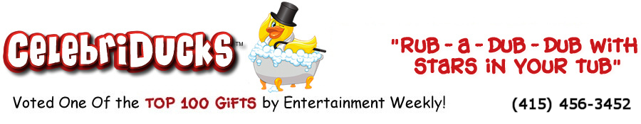

Thank you for your interest in our company. CelebriDucks is the original creator of the first ever collectible celebrity rubber ducks of the greatest icons of film, music, athletics, and history. We have produced CelebriDucks for the NBA, Major League Baseball, the NHL, NASCAR, NCAA Collegiate Mascots, and also people such as KISS, Elvis Presley, The Blues Brothers, The Wizard of Oz, Mr. T, Marilyn Monroe, Conan O’Brien, Betty Boop, and many others.

To date we have sold millions of our ducks while pioneering a whole new collectible. We are also considered the top custom duck manufacturer in the world. Our exclusive limited edition rubber duck collection will continually expand and change as new CelebriDuck rubber duckies are introduced while others are quietly retired to the pond with graceful dignity.

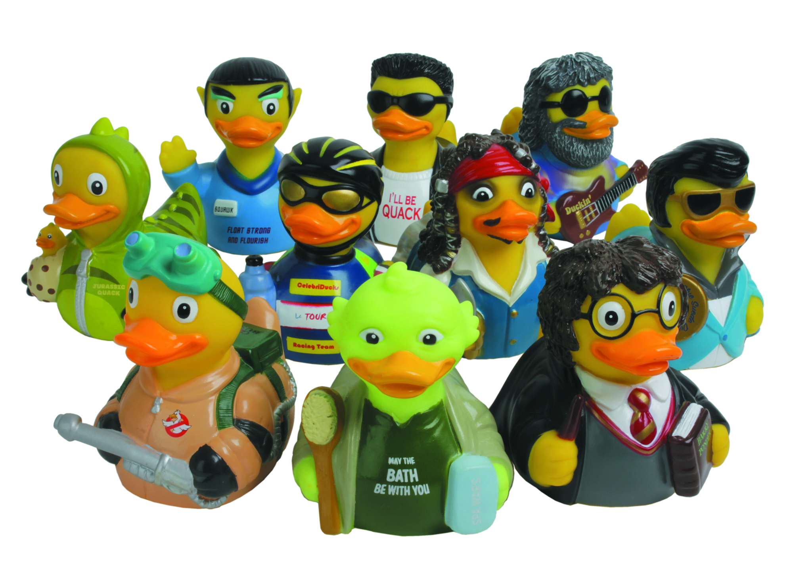

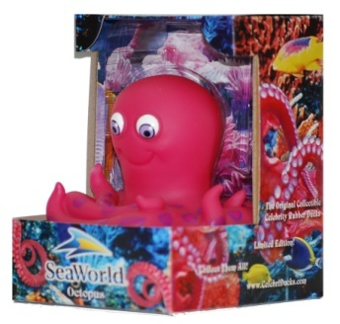
Questions:
What promotional product wins the award for the most KEPT product that is rarely ever thrown away?

What promotional product immediately becomes part of a worldwide Collector's Series that has a HUGE following of serious collectors?

What promotional product has been made in the likeness of Elvis, Michael Jackson, Wizard of Oz characters, The Gorton Fisherman, athletes, politicians and thousands of other characters for professional sports teams, universities, and Fortune 500 companies?

What promotional product can be packaged in a beautiful custom designed gift box that can tell a unique story in full color on all panels and still show off the product?

If you answered: CelebriDucks.... you are correct!
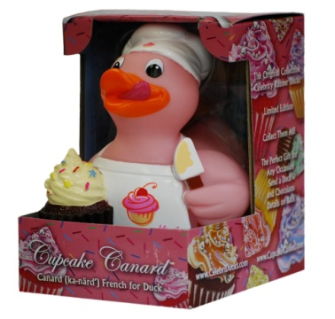
Next time you have a client wanting something unique, collectible and kept forever....Think... what the duck? CelebriDucks!!

Now a little more info about us: CelebriDucks has created an amazing brand which is sold and collected worldwide. Not only do we make some of the finest rubber ducks in the world, but we offer a degree of expertise in all areas of product development. This makes us a one stop shop for people looking to find the most unique and innovative product possible for their customers. There are many reasons why so many professional sports teams and Fortune 500 companies choose to work with us.

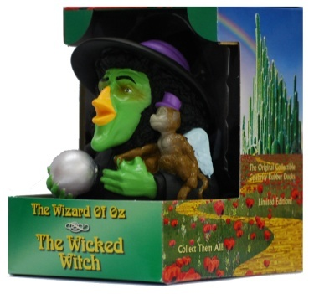
The rubber duck was actually invented in America although all are now made overseas. CelebriDucks has brought the whole rubber duck industry back to the USA and is the only company also manufacturing rubber ducks in America! You can read more in the Made in America section on our website. We do all our artwork and sculpting in the USA and final production at our factory overseas or at our factories in New York and Michigan depending on pricing.

It's a fact that so many promotional products people receive are thrown or given away. What is amazing about CelebriDucks is that people actually hold onto our items which make us one of the most sought after promotional products in the country. Our track record to this effect is nothing short of extraordinary.

There is a reason that we are considered the top custom duck manufacturer in the world. Many people are surprised when they order a custom rubber duck made overseas and get a very hard piece poorly plastic that does not float upright, and has very little detail…just a mass market same old same old. We are considered the Mercedes of rubber ducks which is why the top brands in the world come to us.

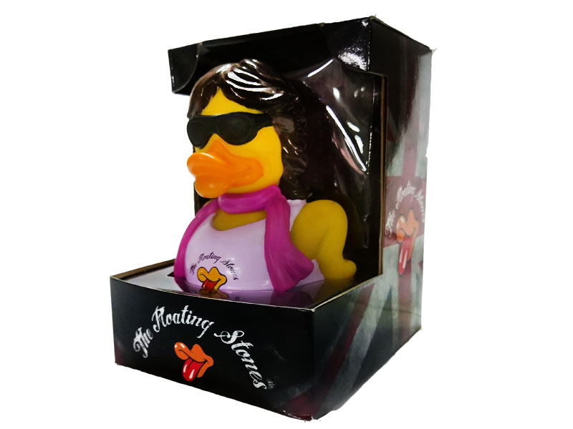
The fact that we are considered the best in our industry means that you are in very good hands. In fact, numerous times we often had to take over jobs from other clients that come to us after getting inferior products from overseas. They are not designed well, do not float upright, let in water and thus mold, and are too hard. Plus they are poorly painted, don’t meeting safety requirements for children (which they have to even if it is for an adult crowd), and are often made with unsafe labor practices. You will have none of those concerns with us. In fact, as the only rubber duck company in the West, we are also the only ones who do all our artwork and sculpting in America. Then we will finish the project based on cost considerations at our small family owned factory overseas unless you wish to use one of our US facilities.

Because we are the only ones in the world who will do small custom runs from scratch at 1-2000 units, we get quite busy as people have no other option but us. Thus our lead times can get a bit long depending on our volume of work at any given time. Please expect at least 4-6 months minimum unless we fly them in. Making a duck seems easy, but there is a lot to it. But in the end, you will have something that is so special and so unique that it will do for your brand exactly what you are looking for.

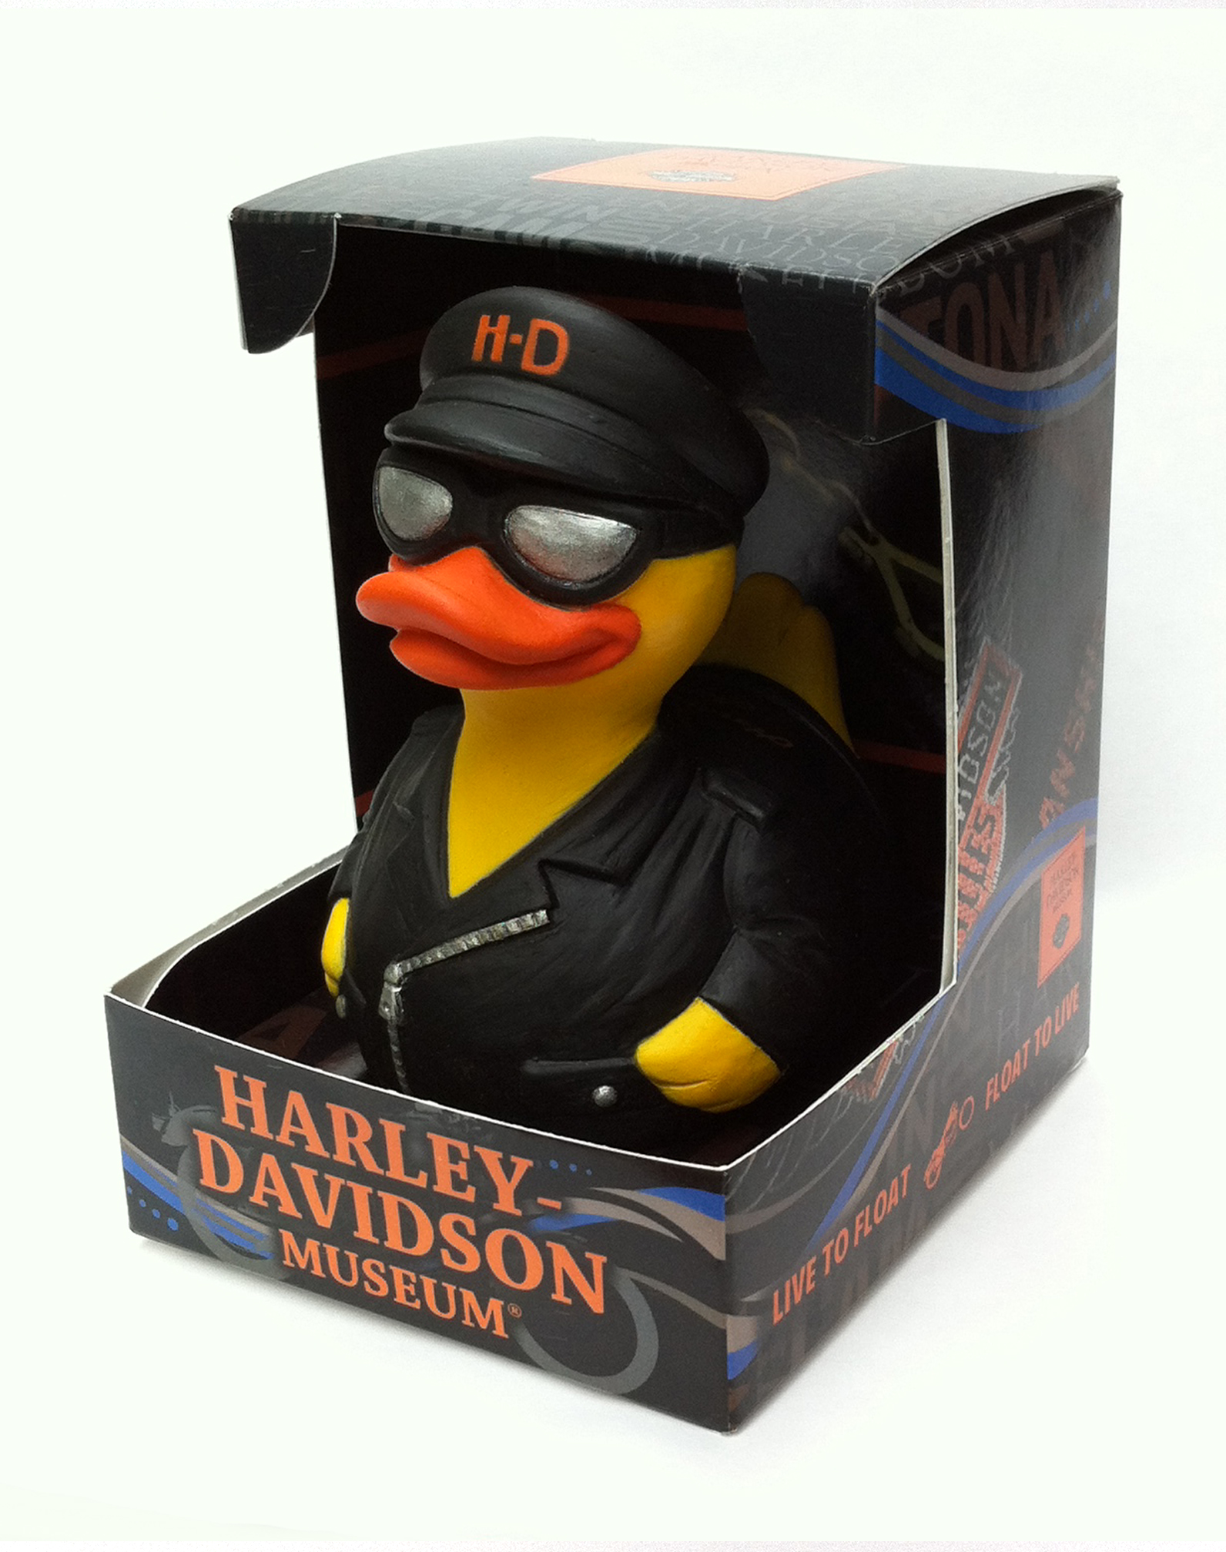
If you want them in the gift box, the perceived value is a $15 to $25 item. Yet, we are just charging you .20 for the gift box! The reason is we are gang running them with our other jobs. There is a one-time $400 design free to create the box, but it will tell the whole story of your brand with pictures and creates a gorgeous impression. If you design the box yourself there is no charge.

CelebriDucks offers a great branding opportunity as anyone getting one will keep it in their home or on their desk at work for years and years and it will look high-end, not inexpensive. That’s what you want and why people use us. And if you do a press release and get them in the hands of the media, so many PR outlets will run with your story. We’ll also have it in our custom duck section on our website with info about your creation in our social media to get you even more exposure.

So in summary:

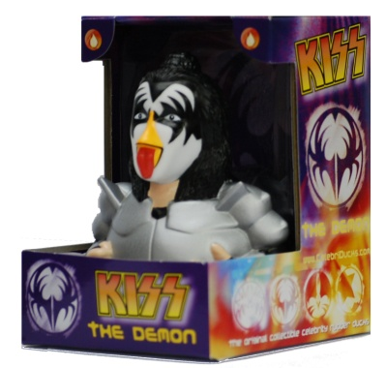
1) The quality of our products is unsurpassed. CelebriDucks are recognized to be the most intricately sculpted and painted rubber ducks in the world. The website pictures are a pale comparison to the actual ducks and packaging in real life. Unlike most inexpensive rubber ducks, CelebriDucks all float upright even in rough water and are sealed to prevent any water from getting inside. They are all lead free, phthalate free, and conform to the strictest government safety requirements for any country worldwide.

2) GREEN and innovative! Let us Green your promotion. Not only have we pioneered a whole new collectible, but we also always strive to come up with unique products. We can make your promotion Green since we are the ones who pioneered the world's first 100% totally recycled rubber duck. Even all our packaging on all our ducks is recycled.

3) Quality Control. How nice it is not to worry about the quality of the end product. It is a common complaint in our industry that what is ordered and what arrives from overseas are not the same. Poor painting, poor engineering, and defective packaging are common. With us you get guaranteed customer satisfaction.

4) Because of our extensive knowledge of how to work through the approval process in terms of artwork and designs, we are able to seamlessly work with our clients in the back and forth design and manufacturing process. Remember, not only do we produce the finest rubber ducks on the market, but previously we were the largest publisher of artwork from television commercials in the country. We created the first ever animation art lines for Coca-Cola, Anheuser-Bush, M&M/Mars, Pillsbury, Nike, and many others.
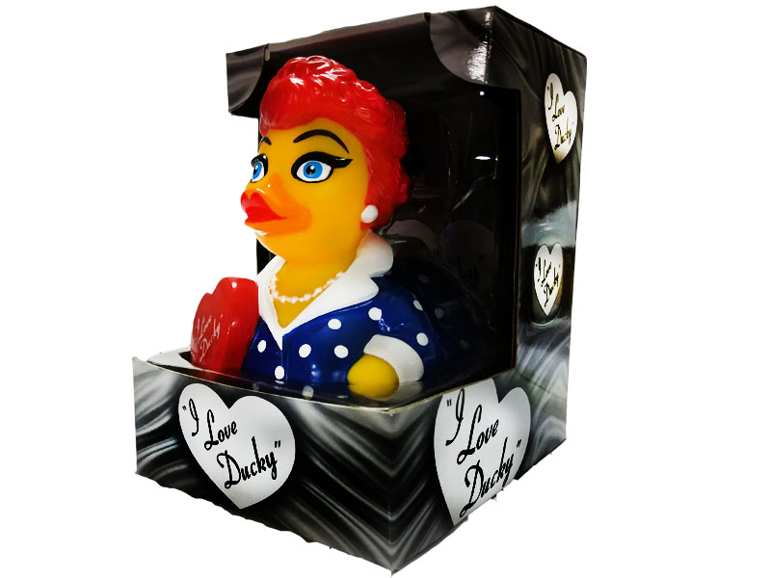
5) Expertise. When you have a tight deadline or a very complex and intricate project that demands real expertise, we are the ones you want to call on. We represent over 30 years of design and manufacturing experience.

6) Reliability. In our entire history we have never missed a deadline. What's that worth for peace of mind for you and the client?... Priceless! Working under pressure is second nature for us.

7) Flexibility. We can create anything. There is virtually no custom project we cannot do in addition to our world class CelebriDucks. If you go to the custom duck section of our website, you can see examples of some of our work and the tremendous number of well-known clients we have done work for.

8) Fair Pricing. For the quality of work we do and all the extras we add, in the end we can be very competitive. When we quote a price, there are no surprise add-ones. Our prices include such things as artwork design, molds, spray masks, etc., except shipping. It even includes our high-end beautiful gift box which we can be customized.

And when it comes to pricing, very often we can find ways to adjust a design or project to help meet your desired price point. We often ship our custom jobs along with our other retail shipments thus saving money in your shipping costs. Although they make a beautiful presentation, our CelebriDucks can also be ordered without gift boxes to save even more.

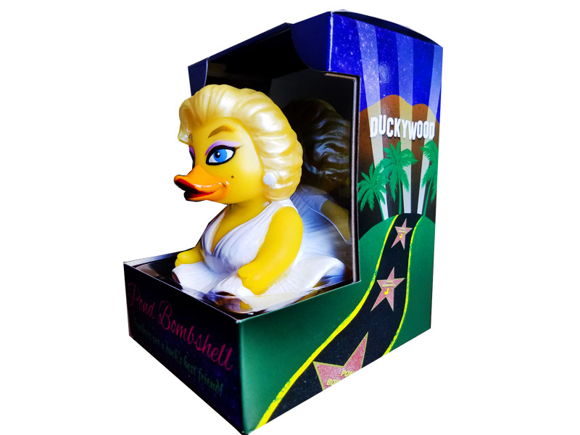
9) PR Value. If you are looking to get fantastic PR, we are as good as or better than any other similar product on the market having been voted one of the top 100 gifts by Entertainment Weekly. The number of media outlets who love our celebrity rubber ducks is quite amazing. The majority of media outlets who receive one of our ducks will actually do a story about your event thus giving our customers tens of thousands of dollars of free publicity.

10) Perceived Value. Due to the fact that we also produce a retail line of CelebriDucks, the end user will tend to hold on to and treasure these beautifully crafted items as opposed to just tossing it away after the event. We are a collectible and have built up a very large collectible market worldwide who appreciate our work.

11) In Stock Celebrity Ducks. We keep a whole line of celebrity rubber ducks which are immediately available as an alternative when you are looking for a unique item for an event. Our range of the greatest icons of film, music, history, and athletics is unsurpassed with everyone from famous musicians and movie stars to NCAA collegiate mascots and sports figures.
12) PVC Free. On our website, in the Good Duck section, you can read more about how we have created the world’s safest rubber duck and the only rubber duck a baby should ever teethe on make out of medical and food grade materials. It is 100% made in the USA in pink, blue, and yellow.

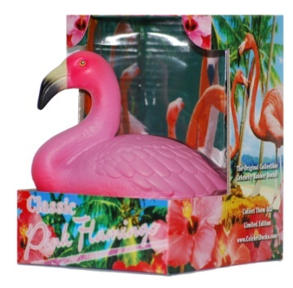
As mentioned, our production times vary depending on the job, but again we recommend that you leave roughly a minimum of 4-6 months from start to finish and give us as much lead time as possible. Even if you find a less expensive product on the market, you will most likely not find a better one. And what we offer in terms of expertise, experience, and a proven track record really puts us above the rest. One look at the Costume Quackers section on our website will show the detail in some our finest work. Please call or write us at any time if you have any questions whatsoever. Our press kit letter and current inventory is listed below. All of us here look forward to the possibility of working together.

Sincerely,
Craig Wolfe,
President
CelebriDucks
415-456-3452
http://www.celebriducks.com

All prices include a custom gift box, product design and sculpting, molds, spray masks, etc. Shipping and a one-time box minor design fee will be added. If you do not wish a gift box, that is fine. If you wish to design your own box, we will send you a template and there is no charge. There is a charge for pad prints which varies depending on how many you wish printed on the product according to each individual design.

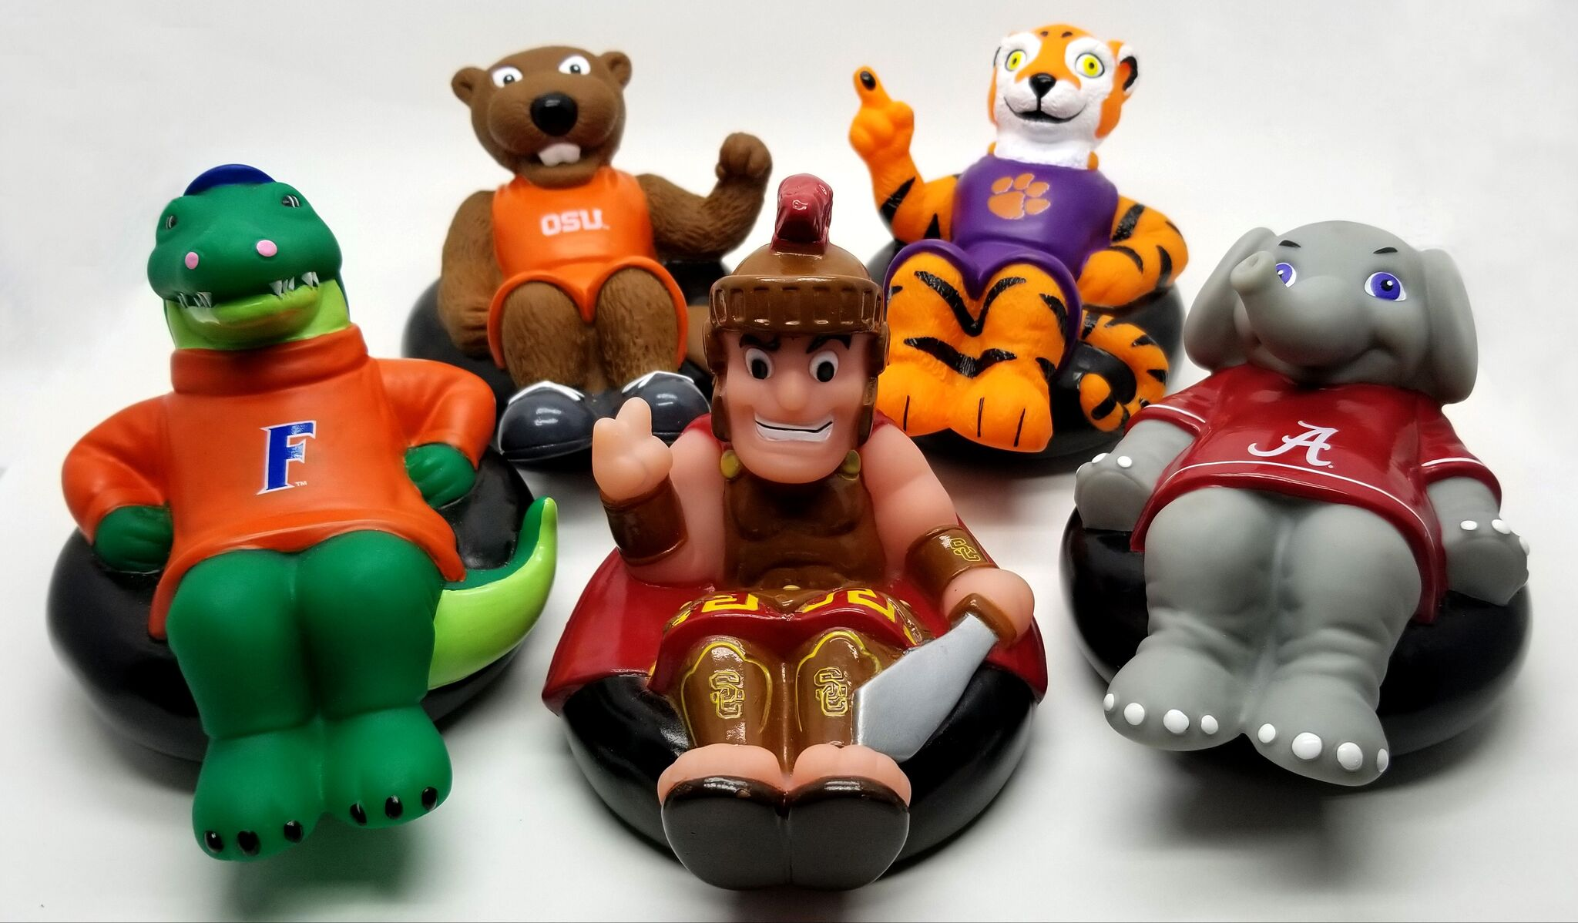

CELEBRIDUCKS
28 Mountain View Ave., San Rafael, CA. 94901
Phone: 415-456-3452 http://www.CelebriDucks.com

CelebriDucks is the original creator of the first ever celebrity rubber ducks of the greatest icons of film, music, athletics, and history. They have produced CelebriDucks for the NBA, Major League Baseball, the NHL, NASCAR, NCAA collegiate mascots and also famous people such as Elvis Presley, Marilyn Monroe, The Wizard of Oz, Michael Jackson, James Dean, KISS, James Brown, The Blues Brothers, and the world's first ever recycled GREEN duck. To date they have sold millions of CelebriDucks and have pioneered a whole new collectible. They are also the only rubber duck company in the USA having returned the industry back to America where it was originally invented and are considered the top custom duck manufacturer in the world.

The company has received a tremendous amount of publicity having been on NBC, Fox, CBS Evening Magazine (three times), CNN, ABC, Showtime, ESPN, VH1, TNT, A&E, Late Night with Conan O’Brien, Who Wants To Be A Millionaire, The Tony Danza Show, The Jimmy Kimmel Live show, and most other television networks, plus written up in Sports Illustrated, U.S. News and World Report, ESPN The Magazine, Maxim, The N.Y. Times, USA Today, LA Times, San Francisco Chronicle, Toronto Sun, Playboy, The Chicago Sun Times, Fortune Small Business, etc.. CelebriDucks have been on Jay Leno’s Tonight Show twice and were voted one of the top 100 Gifts by Entertainment Weekly. The press only continues to build with more and more stories coming out about the company both nationally and internationally.

The company created a Tropical Parrot, complete with Hawaiian shirt and shades, for The Jimmy Buffet Margaritaville Cafés, and successfully sell their Blues Brother’s ducks at all House of Blues venues nationwide. They created the world’s first ever floating Pink Flamingo for Caesar’s Flamingo Hotel in Las Vegas.

ESPN ran a poll on their website for the fan’s favorite stadium give-a-way and CelebriDucks beat out Beanie Babies, Bobbleheads, Pez Dispensers, Lunch Boxes, and Match Box cars. Their ducks have been used by numerous teams in the NBA, NHL, and Major League Baseball such as The Yankees, The Philadelphia 76ers, The Houston Rockets, The Chicago Cubs, and many many others which can be seen in the custom duck section on their website. Their promotional sporting events have been sponsored by companies such as Reebok, Dr. Pepper, Gatorade, AOL/Time Warner, Southwest Airlines, Arby’s, Adidas, Mountain Dew, Chevrolet, Sprite, Dodge, Clarinex, Subaru, Pepsi, Office Depot, Sierra Mist, and many others.

Proctor & Gamble, the largest packaged food manufacturer in the world had CelebriDucks create 200,000 Will Ferrell wash poufs for an Old Spice promotion to tie in with Will Ferrell’s new movie, Semi-Pro.

Gorton Seafood, one of the largest frozen fish companies in the US did a four month national promotion which was tremendously successful with the creation of a CelebriDuck of the Gorton Fisherman. Not only did it sell out, but it was the most successful promotion in their history. This was followed up with another promotion with our duck on over one million packages.

CelebriDucks Current Inventory

80002 Shakespeare
81003 Pink Flamingo
81007 Dorothy Wizard of Oz
81008 Tin Woodman Wizard of Oz
81009 Scarecrow Wizard of Oz
81010 Lion Wizard of Oz
81014 Popeye
81015 Elwood Blues Brother
81016 Jake Blues Brother
81017 Betty Boop
81023 Dr. Frank-n-furter
81030 Mr. T
81032 Alice in Wonderland
81034 Wicked Witch of the West
81039 Gene Simmons - KISS
81071 Cocoa Canard Chocolate Duck
81072 Recycled Green Duck
81087 Cafe Canard
81088 Cabernet Canard
81094 Cupcake Canard
81107 Chip The Ice Cream Duck
81098 Devil Ducky
81099 Holy Smoker BBQ Pig
81100 University of Oregon
81080 Otto the Octopus
10800 Hatched in the USA SAM
10802 Made in America Lila Loon
10804 Pork Chopper - Made in America
81111 Breaking Bath
81112 Spa Wars
81120 Blue Suede Duck
81114 Jurassic Quack
81115 Camo Quacker
81116 Duckinator
81117 Duckin’
81118 On The Pond
81121 Give Geese a Chance
81122 Mister Squawk
81123 Purple Waves
81124 One Pond
81125 Tour de Duck
81126 Mad Quax Pond Warrior
811127 Capt. Quack of the Quackabbean
81128 Goose Busters
81129 Harry Ponder
81130 Paddle Like It’s 1999
81132 Pond Bombshell
81133 Material Bird
81134 Floating Stones
81135 Say Hello to my Lil’ Friend
81136 I Love Ducky
81137 Ziggy StarDuck
81138 The Godfeather
81139 Sargent Peepers Lonely Hot Tub Band
81140 Tasting Away Again in Margarita-Bill
81141 Hunger GameBirds – Quacjniss
81142 GameBirds of Thrones – Mother of Duckies
81143 Aviary Grande – Dangerous Duck Tour
81144 - 101 Duckmations
81145 - SeinFowl A Nestivus Miracle
81146 - Birdo Marsh
81147 - Uniquack
83378 Good Duck Yellow
83379 Good Duck Pink
83380 Good Duck Blue

Spooning Chocolate – Please visit www.CocoaCanard.com

